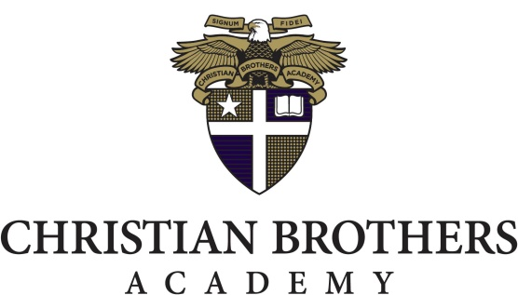

PRESS RELEASE June 9, 2021
Contact: Blaine Drescher ’04
518-452-9809 ext. 133
drescher@cbaalbany.org

CBA Hire Varsity Football Coach
Varsity Football Coach Bob Burns Joins CBA

(Albany, NY) - Christian Brothers Academy is pleased to announce the appointment of Bob Burns as Head Varsity Football Coach.

Bob Burns brings over twenty years of experience as an educator including 19 years coaching varsity football. Over the last six seasons as Head Varsity Football Coach at Troy High School, Coach Burns accumulated a record of 58-4 with 3 undefeated seasons and 2 State Championships. Burns stated, “This success has come through building great relationships with my student athletes and providing them with the tools needed to succeed on the football field and in every aspect of life.”

“Bob has had great success as a football coach in this area” said CBA Athletic Director, Blaine Drescher. “I am looking forward to the opportunity our student athletes will have under his direction. As a school we are committed to raising our football program to the next level and this is another step in making that a reality.”

Bob Burns began his teaching career at St. Patrick’s Academy in Catskill and since 2001, has taught at Sacred Heart School in Troy, NY.

"We are very excited that Bob Burns is coming to CBA as our next football coach,” said Dr. James Schlegel, President of CBA. “Coach Burns is a career Catholic School educator who understands the culture, tradition, and community of CBA. We know he will build upon the work of the great coaches who preceded him. He is a proven winner and I know he will be an excellent role model for our students, a colleague to our faculty, and a proud member of our CBA family.”

ABOUT CHRISTIAN BROTHERS ACADEMY
Christian Brothers Academy is accredited by the New York State Board of Regents and the Middle States Association of Colleges and Schools. Christian Brothers Academy’s mission is to instill Christian values and to provide a demanding academic program within the Lasallian tradition. CBA is committed to meeting the needs of the individual, to develop his full potential, and to guide him toward a role as a contributing member of society.
###

